Kunark

Information from EQAtlas.com

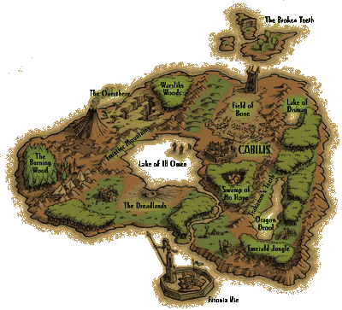
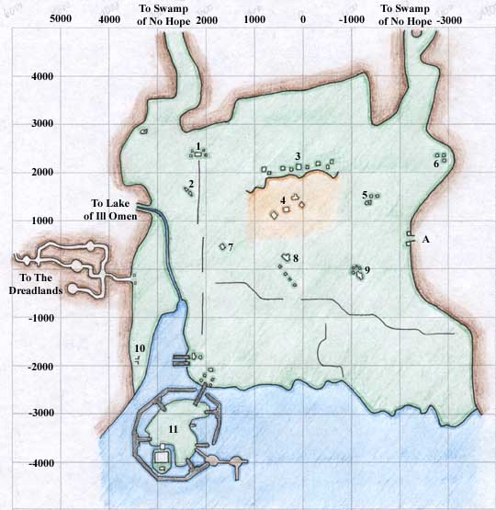
Firiona Vie

Firona Vie - Zone
1 Empty Ruins
2 Empty Camp
3 Ruins
4 "Leech Field" - Ruins with leeches
5 Drolvarg Camp
6 Forest Giant Camp
7 Empty Ruins
8 Empty Ruins
9 Drolvarg Ruins and Camp
10 Underground Tunnel to Building 4 on Firiona Vie Docks
11 Firiona Vie Docks
A To Drolvarg Underground

Firona Vie - Docks
1 Merchant selling Food, Water, Cookbooks, and Mixing Bowl
2 Merchants selling Bags and Boxes
3 Merchants selling Weapons, Medium Plate and Chain Armor, Oven and Forge outside
4 Tunnel inside that leads to west side of the bay
5 Merchants selling Bard Songs, Alcohol, Brewing Supplies and Brew Barrel
6 Merchant selling Monk Weapons
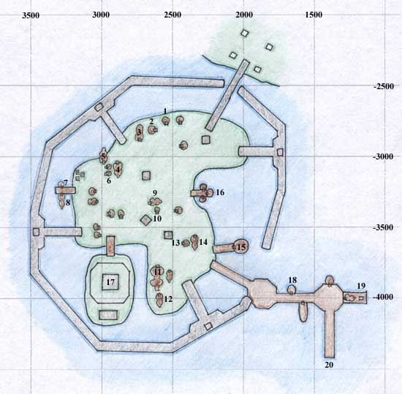
7 Merchant selling Unfinished Bard Instruments
8 Ranger Trainer, Merchants selling All Bow and Arrow Fletching Supplies, High Level Ranger Spells
9 Bank
10 Merchant selling Medium Leather Armor
11 Underwater Tunnel that opens at area 19, also Warrior Trainer
12 Enchanter, Wizard, and Magician Trainers, Merchants selling Enchanter, Wizard, and Magician Spells
13 Merchants selling Most Jewelry Supplies
14 Rogue Trainer, Merchant selling Poison Supplies
15 Merchants selling Large and Small Sewing Kits and Patterns
16 Merchants selling Magic Stones, Potions, High Level Druid Spells
17 Paladin Trainer, Merchant selling Cleric and Paladin Spells
18 Merchants selling Fishing Supplies, Bows and Arrows, Alchemy Supplies, Bags, and High Level Shaman Spells
19 Underwater Tunnel that opens to area 11
20 Boat to Butcherblock Mountains

Location:
On the Southern coast of the continent of Kunark

Adjacent Zones:
Dreadlands, Lake of Ill Omen, Swamp of No Hope, Timorous Deep

Level of Monsters:
25-45

Types of Monsters:
Venomous Lamprey, Frenzied Leech, Drolvarg Savages, Scavengers, Snarlers, and Growlers, Froglok Ton Knights, Shin Warriors, Shin Knights, Tal Shamans, and Nok Shamans, Goblin Battlecasters, Marauders, Plaguebringers, Pillagers, Adepts, and Raiders, Drachnid Webspinners, Weblurkers, Webstranders, Silkspinners, Silkstranders, and Silklurkers, Firiona Drixie, Forest Giant Arbors and Verdants

Notable NPC's:
An Ancient Jasarth, Red Eye Jack, Pirate Destroyer, Pirate Cartographer

Unique Items:
Piece of Medallion, Axe of the Iron Back, Forest Loop, Giant Foremans Tunic, Giant Lord's Tunic, Gunthak Harpoon, Hammer of Flattening, Dark Oak Shillelagh, Shin Gloves and Leggings, Weighted Axe

Indoor/Outdoor:
Outdoor

Description

The land of Firiona Vie is a very wild forest, and also happens to be the site of a beachhead established long ago by the elves of Faydwer. After being long-abandoned, the elves are now returning to this land to rebuild their fortress.

Dangers

This zone is highly dangerous. Virtually every monster in this zone (Firiona Drixies excluded) will attack every creature, no matter what. For that reason, the only "safe" place in this zone is the high elf compound of Firiona Vie, which lends its name to this region.

Specifically there are two new creatures in this zone that are the bane of every traveller. First are the Drolvarg, a highly aggressive breed of gnolls that has taken up residence in an abandoned tomb in the eastern part of the woods. These Drolvargs are a constant nuisance to a traveller in that direction, and have very large, fast moving patrols, forcing you to keep your eyes open.

The other, probably more important, creature are the drachnids. These abominations can be seen wandering the whole forest, although they are more frequent in the western part. They are spellcasters that are around 30th level and are highly aggressive. They also have a tendency to pop into appearance, which I'm not sure is that they are hiding, but more likely related to my computer. Nonetheless, watch for these as well while moving through the forest, as they tend to frequent the route travelled by younger adventurers who arrive at the dock and want to go to Lake of Ill Omen.

Also, druids should be careful to not travel to the guards in wolf form, as they will be killed.

Benefits

This zone provides a large number of creatures to hunt from, and they tend to get more powerful the more easterly you go. It is also safe to pull from either the dock area (although others will hate you) or to the zone by Lake of Ill Omen, although none are super.

Probably the best thing in this zone are the drixies. They may not like you, but they seem to hate everything else in the forest. I doubt you could ever make this work to your advantage, but if you are being chased by something that's going to kill you, run it into a couple of drixies and watch the fun (while you can), knowing that whatever killed you has likely seen its last day as well. Petty, I know... I had the pleasure of watching three drixies drive off two drachnids that had wandered too close. A short time later, I saw a large Drolvarg nearly kill a drixie, only to have two more drixies wander by, heal the injured one, and proceed to beat the crap out of the drolvarg. They may not help you, but they're fun to watch...

Travelling To and From Firiona Vie

The boat to Timorous Deep and Butcherblock Mountains arrives at the dock located at -4400, 1400.

To travel to Lake of Ill Omen, follow the stream just west of the ramp to the mainland. This stream will take you into some hills and to the Lake at approximately 1290, 3500. In the Lake the location is 1300, -4300.

There are several zones to the Swamp of No Hope scattered across the northern edge of the forest.

